Drive, Putt and Chip Youth Clinic
Get ready to go to the Masters!
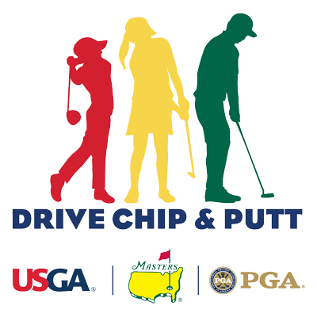
Clinics are open to youth 7 -15 years of age.
We will prepare you for all events.
Cost is $85.00 per person.
Sign up for any of the following dates:
Saturday April 11, 2020 at 12:00 – 2:00
Saturday May 16, 2020 at 1:00 – 3:00
Saturday June 13,2020 at 1:00 – 3:00

NAME: _____________________________________________________________________________
ADDRESS: __________________________________________________________________________
CITY: ______________________________________ PHONE: _________________________________
CREDIT CARD: _________________________________________EXP. DATE: __________CVV: ______
E-MAIL ADDRESS: ____________________________________________________________________
Do you need Clubs?________________ AGE: ______________
Session:____________________________

